Discussion Section Unique Number:

Discussion Question Set 5

Answer any two questions from the list given below and bring a written/printed copy of your answers with you to the discussion sessions this week (Feb 22 & 23).

- Name the following molecules and label the high and low energy bonds.
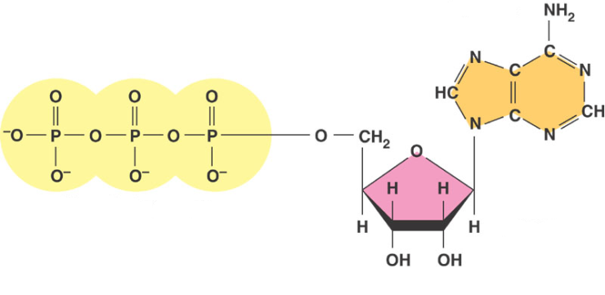
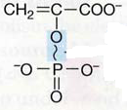

- Name and describe the three methods by which ATP can be synthesized.

- Compare the regeneration of NAD in aerobic respiration, anaerobic respiration and fermentation.

- Is NADP preferentially used in anabolic or catabolic pathways? What about NAD?

- Why is anaerobic respiration less efficient than aerobic respiration with respect to ATP synthesis?

- Is the TCA cycle amphibolic? Defend your answer.

- What are the two functions of carbohydrates in the cell?

