Name (Last, First)
Discussion Section Unique Number

Discussion Question Set 12
Answer any two questions from the list given below and bring a written/printed copy of your answers with you to the discussion sessions this week (April 26 & 27).
- How does an Hfr strain transfer chromosomal genes?

- Which of the following processes would be affected by the addition of DNase to the media: conjugation, transduction or transformation? Explain your answer.

- Why isn’t the entire chromosome transferred during an F’ x F⁻ conjugation?

- How could gene ZZ be transferred into an F⁻ strain if it is far away from the direction of Hfr transfer? Hint: think beyond Hfr conjugation
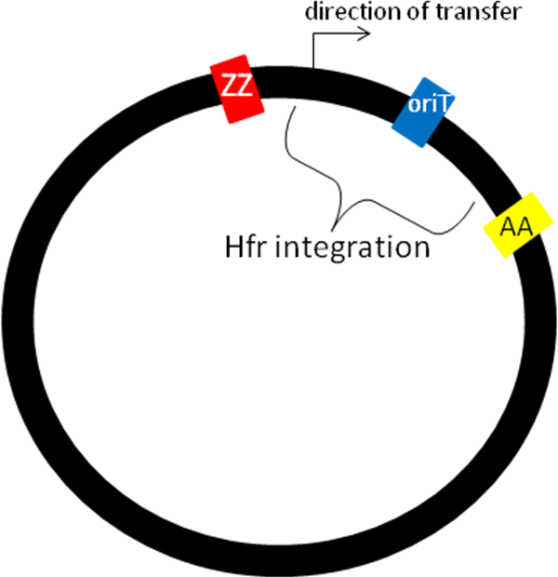
- Why is linear DNA transformed at lower frequency than circular DNA?

- What are two ways E. coli can be made competent?

- How does the mechanism of transformation differ between S. pneumoniae and H. influenza?

- How are chromosomal genes transferred during generalized transduction? Is this gene specific? During what phage cycle does this occur?

- Why does λ(lambda) phage transfer bio and gal at a higher frequency as compared to other genes? During which part of the phage life cycle does this occur?

- What is the role of the viral capsid in generalized transduction vs. specialized transduction?

- How can the three modes of gene transfer be used in genome mapping?

