Questions

1. What is driving force for apical extension
- Not known but probably partly turgor pressure
- Tips have high osmotic pressure
- Tips blow out in dilute acids

2. Evidence for tip growth of molds?

Burgeffs experiment
~ 1900
etc.

3. How is wall synthesized to -> tip or bud growth?

Evidence for in situ synthesis of cell wall microfibrils

a. Cell fractionation studies - sugar nucleotide transferases for synthesis of β glucans & chitin present in plasma membrane

b. Chitin synthase in Zygomycota has been demonstrated to be localized in hyphal tips

c. Zoospores prior to encystment have no demonstrable preformed micro-fibrils in their cytoplasm

d. EM tends to demonstrate that wall microfibrils are not carried to wall synthetic loci in apical vesicles.*

* Vesicles seem to be transporters of amorphores matrix materials.
Heteropolysaccharides
Mannoproteins
etc.
190a

Evidence for in situ synthesis of cell wall microfibrils (cont)

e. Demonstration that at least some, if not all chitin is synthesized, most likely, in a vectorial way as demonstrated by unilateral formation of chitin by isolated plasma membrane.

Pretreatment of protoplasts with gluteradehyde before lysis --> no effecting chitin synthesis

Pretreatment of disrupted membranes with gluteraldehyde inhibited vectorial synthesis
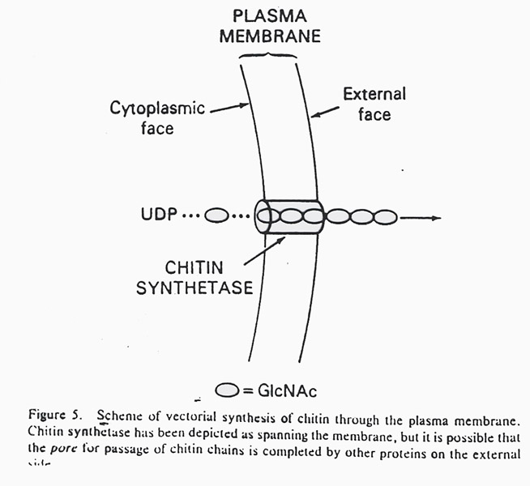
190c

Indirect evidence for a role for hydrolytic enzymes in wall synthesis

a. Wall hydrolytic enzymes can be isolated from hyphal tips and yeast buds

b. Is a positive correlation between concentration of hydrolytic enzymes and rates of tip extension and hyphal branching

c. Fungal hyphae have intrinsic ability to execute carefully controlled dissolution of own wall. e.g. - clamps, anastomosis, bud emergence, branch formation

d. Hyphal tips highly susceptible to disruption, e.g., tips blow out in dilute acid solutions
193

Possible implications

1. Fungal cell wall synthesis depends on a gradient of cell wall synthesis accompanying a gradient of cell wall lysis.

2. For this to occur lytic and synthetic components and machinery must be compartmentalized.

How? Vesicles??
194

