**(8, 6, 6)**

**1. (a)** How is c-di-GMP synthesized in bacteria? What three notable features can you think of that are shared between enzymes that make and break c-di-GMP? **(b)** What is the main role of c-di-GMP in bacteria? Describe two effectors that bind c-di-GMP and fulfill this role. **(c)** We discussed two examples where TCS signaling interacts with c-di-GMP signaling. Draw a diagram showing a known or hypothetical signal relay between TCS and c-di-GMP signaling proteins (indicate relevant domains) which results in c-di-GMP production.

***(a)*** *It is synthesized from 2 GTP molecules by enzymes called guanyl cyclases. These enzymes are 1. Generally located in the membrane to detect external signals, 2. Linked to signaling modules such as Rec, Pas, HAMP and 3. Are numerous, for example E. coli has 12 guanyl cyclases and 12 phosphodiesterases.*

***(b)*** *The main role is to inversely regulate motility and biofilm formation. 1. YcgR::c-di-GMP serves at a flagellar motor brake. 2. LapD::c-di-GMP controls expression of the adhesin LapA.*

***(c)*** *Signal →Histidine kinase (Dhp-His) → Response regulator (Rec-Asp) – GGDEF → c-di-GMP*

**(8, 6, 6)**

**2.** LapD mediates biofilms by producing surface-attached LapA adhesin. A schematic of LapD protein is shown in the diagram below. **(a)** Is LapD a DGC or a PDE? How do each one of the LapD domains – Output, HAMP, GGDEF, EAL - participate in c-di-GMP signaling and biofilm formation? **(b)** LapA production is regulated by phosphate levels. The PDE RapA is expressed at low Pi levels. Under these conditions, would LapA form a biofilm? Justify. **(c)** You learned of other examples where c-di-GMP controls cell fate in *Caulobacter* (PleD), surface sensing in *Pseudomonas* (WspR) and envelope stress in *E. coli* (YfiN). What are **two** common features of these systems that are different from LapD?

**[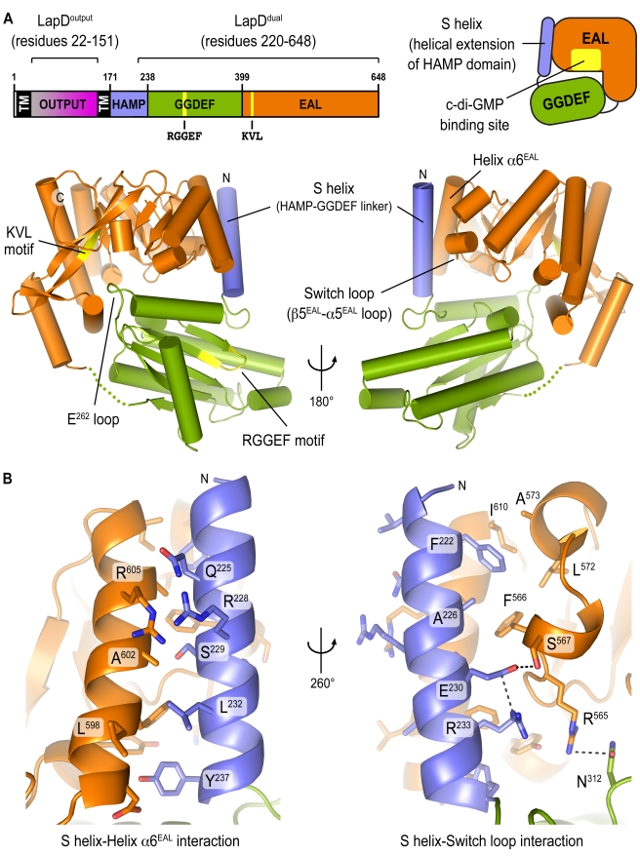](http://www.ncbi.nlm.nih.gov/pmc/articles/PMC3032553/figure/pbio-1000588-g001/)**

***(a)*** *LapD is neither a cyclase nor a phosphodiesterase because its consensus GGDEF residues are degenerate and the EAL domain had other mutations that make it non-functional as a PDE. However, EAL can still bind c-di-GMP and regulate protein activity allosterically. Conformational changes in the cytoplasmic domain are transmitted via the HAMP domain to the periplasm, where the periplasmic ‘output’ domain sequesters a protease LapG, preventing it from cleaving the LapA adhesin, which remains attached to the cell surface and forms biofilms.*

***(b)*** *RapA is a PDE so it degrades c-di-GMP, which is required to activate LapD. Without c-di-GMP, LapA will not be retained on the cell surface, so a biofilm will not form.*

***(c)*** *Lap does not have enzymatic activity and transduces signals inside-out, from the cytoplasm to the periplasm. The other three examples make c-di-GMP and signal outside-in.*

*1. In Caulobacter at the flagellar pole, the developmentally regulated Div J kinase phosphorylates the RR PDE, whose output domain is a DGC. PleD activation is required for flagellar ejection.*

*2. In Pseudomonas, surface sensing via an MCP-like pathway phosphorylates the RR WspR, which also has a DGC output domain. C-di-GMP so produced binds to the transcription factor FleQ to control biofilm formation.*

*3. In E. coli, envelope stress activates a DGC YfiN via a periplasmic PAS domain to interact with the cell division machinery and inhibit division.*

**(6, 7, 7)**

**3.** There are two ways to stop the flagella motor in *B. subtilis* and *E. coli* as summarized in the figure below. **(a)** What upstream events lead to one or the other final outcome, and what exactly is proposed to happen at the motor in each case? **(b)** Blair *et al*. found that EpsE was inhibiting motility by paralyzing flagella rotation. Motile suppressors of EpsE mapped to FliG and disrupted their interaction. If EpsE is really functioning like a clutch, where else could the suppressors have mapped? **(c)** Two different models were proposed for how YcgR::c-di-GMP (YcgRc) acts as a brake. Blair-Harshey said that YcgRc binds to FliM to destabilize FliG and disrupt MotA-FliG interaction, while Jenal said YcgRc binds to MotA to do the same thing. Using a fluorescent fusion of YcgR (YcgR-GFP), propose an experiment to distinguish between the two models.

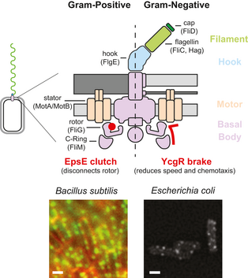

***(a)*** *EpsE is in the middle of an extracellular polysaccharide operon which is normally repressed. Removal of repression suggests commitment to a biofilm mode. EpsE binds to FliG and disengages the rotor, preventing flagellar rotation within the biofilm matrix. YcgR is transcribed as part of the flagellar regulon, binds to FliM and is always associated with the motor. When c-di-GMP levels begin to rise, likely due to activation of DGCs or repression of PDEs, YcgR::c-di-GMP likely either prevents CheY~P binding to FliM and/or changes FliG conformation to induce a CCW bias; at the same time, it might disrupt FliG-MotA interactions to disrupt proton flow and slow the motor.*

***(b)*** *If EpsE is disengaging the FliG from MotA, then one might expect to find motile suppressor mutations in MotA that strengthen the MotA:FliG interface and resist the action of EpsE.*

***(c)***  *YcgR-GFP should localize to the basal body (BB) in WT and MotA mutant if Harshey-Blair model is correct. YcgR-GFP should localize to the BB only in the WT but not in a MotA mutant if the Jenal model is correct.*

**(4, 4, 4, 8)**

**4.** You learned about YfiN, which stops cell division by interacting with FtsZ in E. coli, in response to envelope stress. However, as shown in the diagram below, the guanyl cyclase activity of YfiN must first be turned on in response to redox stress. **(a)** Design an experiment to activate the guanyl cyclase without redox stress. **(b)** What physiological state are bacteria expected to be in before they arrest cell division? **(c)** If these bacteria also expressed LapD, would this state change? **(d)** You want to know how YfiN interacts with FtsZ to inhibit cell division. FtsZ is an essential protein. You isolate suppressors that continue to divide when exposed to envelope stress. Where would these mutations map?



***(a)*** *Delete YfiR, which appears to repress YfiN in the diagram.*

***(b)*** *They must have turned off motility and settled into a biofilm if c-di-GMP levels are high.*

***(c)*** *No, because LapD would signal adhesion production in response to c-di-GMP.*

***(d)*** *They would most likely map to YfiN either in the region that interacts with FtsZ or in a region that prevents the conformational change that exposes this region for interaction in response to envelope stress. They could map to FtsZ as long as the mutation does not interfere with its essential function.*

**(7, 5, 8)**

**5*.*****(a)** As shown in **A**, tryptophan can be converted to indole by TnaA, and indole can be converted back to tryptophan by TrpB. As per the model for indole signaling suggested by Vega et al., which of these two strains - Δ*tnaA* and Δ*trpB –* growing in LB, is expected to generate more persisters and why? **(b)** If a Δ*mtr* mutation was additionally introduced in each of the two mutant strains, how would the persister population be different in the double mutant compared to the single mutant? **(c)** In **B,** WTcells growing in minimal media are more susceptible to antibiotic without added indole compared to indole addition (purple bar). Δ*tnaA,* which cannot make indole, shows a WT response, indicating that not much indole is being made in WT either. Why then does the *Δmtr* strain show better survival compared to WT or *ΔtnaA*? Hint: Bacteria are growing in minimal media.

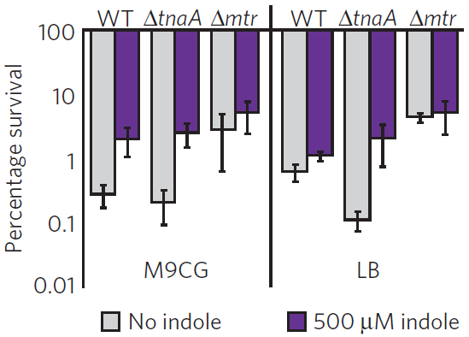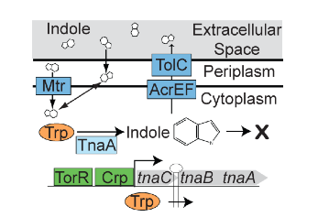

**B**

**A**

TrpB

***(a)*** *According to the data presented by Vega et al., indole signals from the periplasm or extracellular space, because deletion of the indole transporter Mtr did not abolish signaling. The ΔtnaA strain should not signal because it does not generate indole, but the ΔtrpB strain should, since it accumulates indole, which should be secreted. Thus, the ΔtrpB strain should generate more persisters.*

***(b)*** *Mtr is the indole transporter. Indole is thought to signal from the periplasm. Therefore the persister population could increase in the ΔtrpB Δmtr compared to the ΔtrpB strain, since more indole will accumulate in the periplasm.*

***(c)*** *Even though there is no Trp in the minimal medium, the bacteria must synthesize Trp from scratch in order to make proteins and grow. Likely, there is not enough Trp for indole production. However, if even small amounts are made and being exported out, indole levels in the periplasm may rise in Δmtr, giving the Δmtr mutant a small survival advantage.*

**(20)**

**6**.The figure below from the Vega et al. paper shows that a subset of the bacterial population grown in a microfluidic chamber is bright (II) because it has turned on genes that convert tryptophan to indole. When antibiotic is added to these cells in III (arrow), only the indole-producing cells survive (IV, V). You are given three more hours to continue the experiment in the same device to determine if the survivors are persisters or are genetically resistant to the antibiotic. What will you do? Justify your answer.

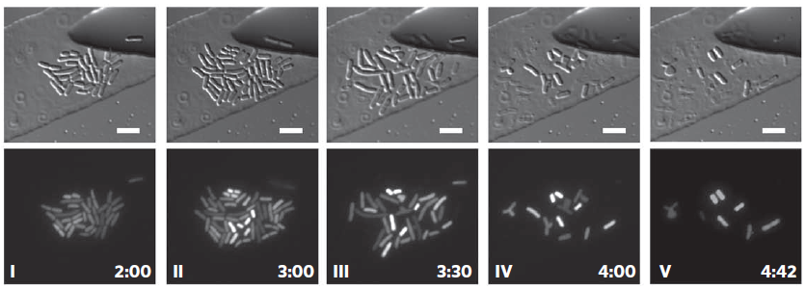

*The simplest experiment would be to leave the cells in the antibiotic medium and photograph them hourly for the next three hours. If they are resistant, they will start to multiply and grow in the continued presence of the antibiotic. Persisters are only phenotypically resistant to antibiotics, not genetically resistant; they have shut down metabolism in order to survive the antibiotic. If they are persisters, they will not grow.*

*More complicated experiments would be to stimulate them metabolically. Persisters should now die.*

*Or, add multiple antibiotics which the persisters are expected to also be to resistant too. However, some resistant cells are also known to turn on efflux pumps to export multiple drugs outside.*

**(7, 5, 8)**

**7.** You learned about several secretions systems is gram-negative bacteria.The Sec system inserts proteins into the inner membrane and the Bam system into the outer membrane. In addition, there are systems labeled I-VII which export proteins outside. **(a)** Flagella and needles are assembled by the type III system. Which parts of these structures are built by this system? Do you think their assembly would need Sec and Bam in addition? Justify. **(b)** What structure is the Type VI secretion related to and how? How does this system sense danger to increase inter-species competitiveness, and what might be the sensing mechanism? How might this system avoid killing sisters? **(c)** A bacterial contractile structure related to T6SS is exploited by a tube worm to metamorphose from a larvae to an adult. Why do you think the worm uses the bacteria as a developmental signal and what do think the bacteria derive from this association? (Speculate, because there is no set answer)

***(a)*** *The parts corresponding to the periplasmic rod and the external filament/needle. Yes, Sec and Bam will be required because the basal structure has rings in the inner and outer membranes.*

***(b)*** *Phage tail contractile machinery but inside-out. Pseudomonas was seen to only lyse Vibrio cholera that had a T6SS (non-functional), suggesting that contact with such a structure is a signal to fire and kill. There might be receptors either on the cell surface or on the surface of the external T6S structure for recognition of the ‘enemy’ T6S structure. Sister killing might be avoided by encoding an immunity function of some sort that does not recognize ‘self’.*

***(c)*** *Perhaps the bacteria occupy a niche that is ideal for tube worm development, so the presence of the bacteria signal an optimal environment. Just as only some bacteria lyse, perhaps only some larvae benefit, while others are killed. The surviving bacteria might use the dead larvae as food.*