**(4, 4, 4, 8)**

**1.** **(a)** What is the main difference between OCS and TCS systems, and what advantage might the latter have over the former?

**In OCS, a single cytoplasmic protein senses the ligand as well as controls the output response. In TCS, a membrane protein is generally the sensor kinase and a second cytoplasmic protein is the phosphorylated response regulator. TCS system can directly monitor the external environment.**

**(b)** What is the predominant output (downstream effect) of TCS systems and how is this different from the OCS output?

**The predominant output of TCS systems is transcription regulation, which is the same as in OCS systems.**

**(c)** How is the chemotaxis system related to TCS systems?

**The CheA kinase in the TCS system of chemotaxis is in the cytoplasm (not in the membrane), and senses external ligands through membrane chemoreceptors to which it is attached.**

**(d)** What is a phosphorelay and how does the phosphoryl group travel in a relay? Is the His residue always on a kinase? Give an example of a pathway with a relay. What advantage would the relay provide in this pathway?

**Phosphotransfer from His to Asp to His to Asp and so on, is a relay. The His residue can be on a protein with no kinase activity (Hpt); however, the transfer must begin from a HK and then move via H-D to D-Hpt. The sporulation cascade of *B. subtilis* is a relay. Many phosphatases that monitor the vegetative state of the cell act along the relay to remove phosphate groups and terminate the relay if conditions favor vegetative growth, thus preventing commitment to sporulation.**

**(5, 4, 5, 6)**

**2**. **(a)** What is the basis of using covariance to determine interaction specificity between two proteins?

**An interacting pair of proteins must have a set of amino acids that confers specificity. During the course of evolution, these specificity-determining residues co-vary i.e. any mutation in an interacting residue of one partner must either revert or be compensated or by a secondary mutation in the cognate partner so that their interaction is maintained. Identifying co-varying residues, helps to identify their interacting surfaces.**

**(b)** How do bacteria prevent cross-talk between their many TCS systems?

**The DHp residues of the kinase show exquisite specificity for the residues around the Asp pocket of the RR.**

**(c)** According to the Skerer study, how exquisite is the HK-RR specificity?

**As exquisite as 3 amino acid residues.**

**(d)** Is the cartoon below representative of the CheA kinase? Justify. What are the functions of DHp and CA domains?

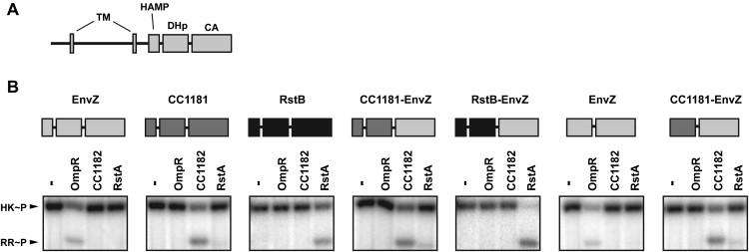

**No, it does not, because the CheA kinase is in the cytoplasm and does not have the membrane-localizing TM domains or the HAMP domain. DHp is the dimerization and histidine phosphotransfer domain, and CA is the catalytic domain which binds ATP and phosphorylates His in the DHp domain.**

**(7, 5, 8)**

**3.** The figure below is from the re-wiriing paper by Skerer *et al*. 2008. EnvZ kinase senses high osmolarity.



**(a)** EnvZ missing the periplasmic and TM domain (compare **A** and **B**) was observed to phosphorylate its RR (OmpR) *in vitro* in the absence of a high osmolarity signal. How is that possible?

**All kinases have an unstimulated basal autophosphorylation rate, which is being used to phosphorylate the kinase invitro with radiolabeled ATP.**

**(b)** If you want to see CheY phosphorylation, what must you change in any one of the first three kinases shown? Why?

**Substitute the DHp domain of CheA with that of any of the three kinases. Residues in this domain interact with the RR as determined by both crystal structures and the high covariance.**

**(c)** If the RstB-EnvZ chimera were to be tested *in vivo*, what additional changes to the chimera would be required to respond to osmolarity, assuming all the downstream signaling components are present for the response?

**The TM and DHp domains of EnvZ must be added back. The former will respond to osmolarity, and the latter will allow interaction with OmpR.**

**(6, 7, 7)**

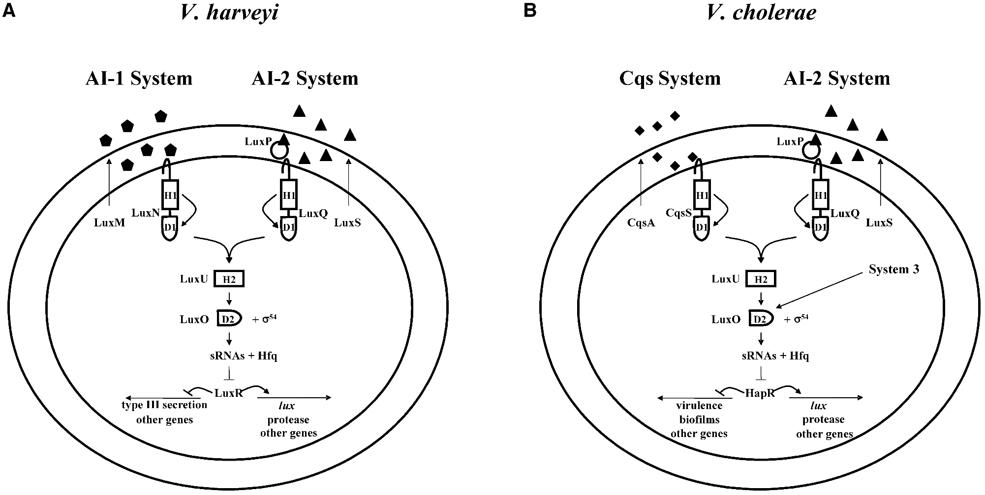**4.** *Vibrio harveyi* has two quorum sensing systems for regulating luminescence, as shown in **A.** They transduce the signal by a His-Asp relay pathway as indicated in the diagram. LuxO is the RR that, assisted by 54, turns on transcription of sRNAs, which destroy LuxR mRNA. LuxR turns on genes for bioluminescence (*lux*). The luminescence curves of wild type (WT) various mutants in the signaling pathway are shown in **B**.

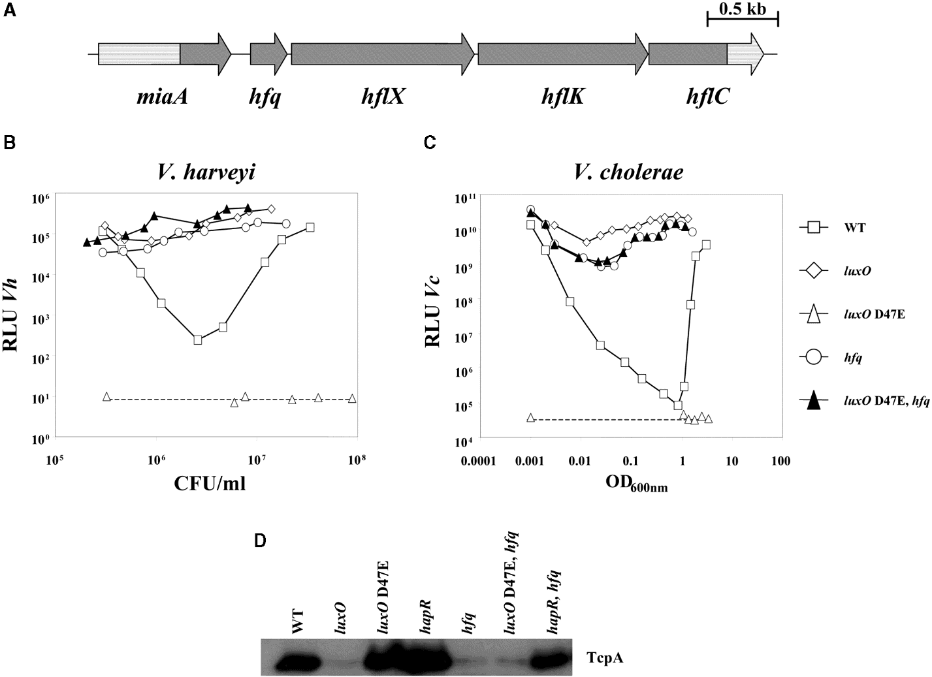

**B**

**(a)** Since bioluminescence is elicited at high cell densities, are the kinases activated or inactivated by the autoinducers at high densities? Explain your logic.

**Their kinase function is inactivated at high densities. When the phosphorylation cascade is active, it leads to transcription of sRNAs that destroy the LuxR message. LuxR is a positive regulator of luminescence.**

**(b)** The *luxO* D47E mutant is constitutively dark (**B**); predict and justify whether this mutant is inactive or constitutively active.

**The D47E mutation likely makes it constitutively active, so it will make sRNAs and destroy the LuxR message.**

**(c)** Name a mutation in the pathway (other than those shown in **B)** that would also be always bright. Justify.

**A sigma 54 mutant would be bright all the time because no sRNAs would be made, so no degradation of the luxR message.**

**(6, 7, 7)**

**5.** The PhoPQ TCS system is essential for Salmonella virulence. The figure below (Mg-sensing lecture; from Cromie et al. 2006) shows Mg2+ regulation of the *mgtA* gene, whose transcription is controlled by the PhoPQ system. RT-PCR is being employed to monitor transcription of the indicated regions (a & b) across the gene.

[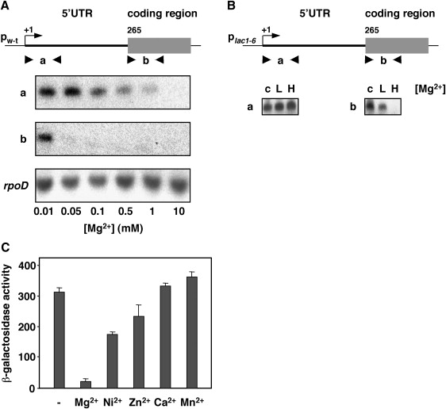](http://www.sciencedirect.com/science/article/pii/S0092867406002947#gr1)**(a)** What signal is activating the TCS system and in what two ways is it detected in this system?

**Mg levels are detected by two targets: 1. The kinase PhoQ responds to low extracellular Mg to phosphorylate PhoP, which turns of transcription of many genes including the Mg transporter MgtA. Intracellular Mg levels act as a riboswitch to further control mgtA mRNA transcription.**

**(b)** What do results in the figureshow about the relationship of Mg to transcription across the gene? How are these results related to gene function?

**Mg++ attenuates transcription in the UTR region and abolishes it in the coding region. rpoD is a control for transcription from a Mg-independent gene. MgtA transports Mg into the cell. When Mg++ levels are low, mgtA is expressed to bring in more Mg into the cell. RNA fold programs suggested the existence of 3 stem-loop structures in the UTR RNA. Alternate folding of these loops in the presence of Mg++ was shown to control mgtA expression.**

**(c)** You are asked to rewire Salmonella to survive in a macrophage by importing Mg in response to ligands recognized by the chemotaxis system. You are allowed only one swap. What two proteins will you choose? What ligands will work?

**Substitute the DHp domain of CheA with that of PhoQ. The amino acids/sugars that bind to the chemoreceptors should modulate PhoQ activity. However, these ligands normally inhibit CheA. So perhaps a repellent that stimulates CheA would to allow mgtA transcription.**

**(6, 8, 6)**

**6.** In the ‘Social cheating’ paper by Sandoz *et al*., long-term growth of a wild-type culture on Caseinate but not CAA (casaminoacids), led to accumulation of Protease- and Nuh- mutant phenotypes. All of these phenotypes were due to mutations in *lasR*, which encodes the receptor for the autoinducer C12-HSL. The same mutant phenotypes (i.e. Protease- and Nuh-) can be generated if the mutation was in *lasI*, which encodes the synthase for C12-HSL, yet *lasI* mutants were not observed.

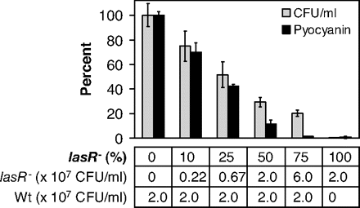

**A**

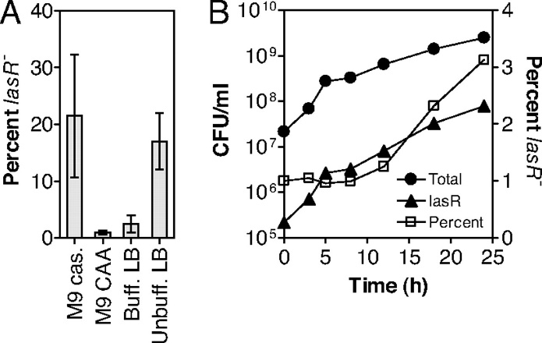

**B**

**(a)** Why were *lasI* mutants not observed?

**Cheaters profit by virtue of their improved fitness in a mixed culture. C12-HSL is freely diffusible, so lasI mutants would still get C12-HSL from wild-type bacteria, and would still incur a metabolic cost – hence they would not be ‘cheaters’. Alternatively, such mutants would lower the strength of the autoinducer ‘signal’, decreasing fitness of both themselves and the wild-type.**

**(b)** The figure **A** above shows that during growth on caseinate, if you mix a wild type culture with a *lasR* mutant even at a 90:10 ratio, the culture grows poorly. Why? How does your answer explain the fact that despite accumulation of *lasR* mutants in the evolution experiments shown in Fig. 2 in the Sandoz paper, the culture continued to grow?

**The lasR mutants are using the public goods from the wild type (proteases) without sharing the cost of making them. Therefore, they have an initial growth advantage but soon use up the caseinate and cannot degrade it themselves, so the culture grows poorly. In the evolution experiments other mutations arose that were protease+, hence were sharing the cost.**

**(c)** In figure **B**, a 100:1 mixture of wild type to *lasR* strains was grown on the indicated media for several growth cycles. Why are LasR mutants enriched in casienate (cas) but not in CAA media?

**LasR mutants are at a growth advantage compared to wild-type in the caseinate medium. This is because they can access ‘public goods’ (enzymes that degrade caseinate) made by wild-type, without investing the energy to produce the goods themselves. These goods are not needed during growth in CAA, so there is no advantage in accumulation of such mutants there.**

**(12, 8)**

**7**.  **(a)** In the diagram on the right below, an R1S1 parent can give rise to R2S1 or R1S2 variants. This diagram labels R2S1 as ‘cheater’ and R1S2 as ‘lame’. The cheater, but not the lame intermediate, is proposed to drive diversification of QS systems by giving rise to ‘novel’ variants R2S2. **1.** Based on the diagram on the left, what is the mechanism by which the cheater would ‘drive’ this diversification? **2.** Why would R1S2 not play a similar role?

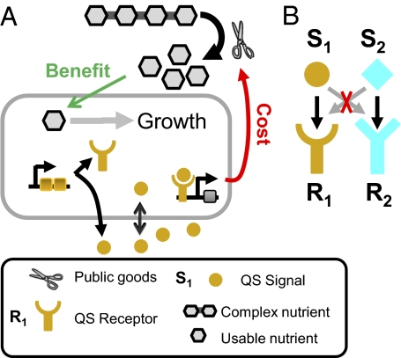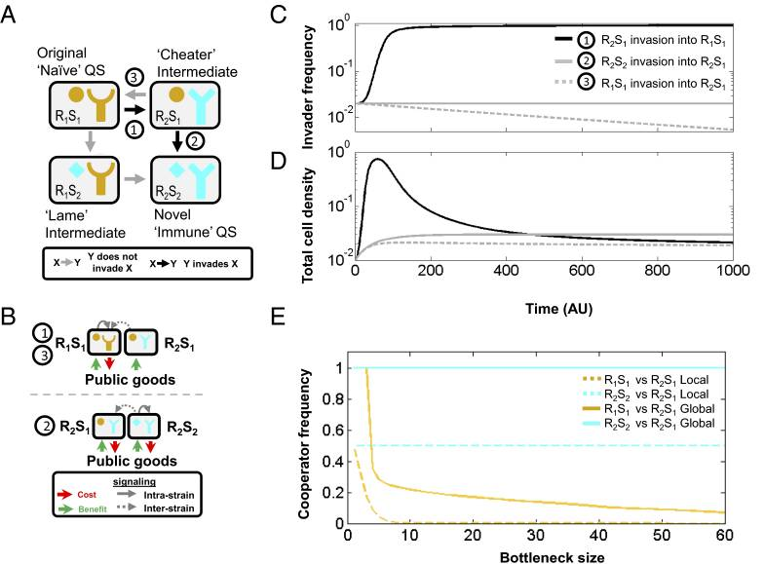

**1. The cheater R2S1 is causing loss of fitness to the ‘cheetee’ R1S1 because it is using ‘public goods made by R1S1 but not contributing to them. The diverged strain R2S2 will perform better than the original strain R1S1, when each competes with the intermediate cheater strain R2S1, because R2S2 is immune to cheating. Thus, the presence of R2S1 is positively selecting for the success of the new strain R2S2. 2. R1S2 is labeled lame because it is still contributing public goods and hence is not a cheater. Therefore, R1S2 is not causing a loss of fitness to the original strain R1S1.**

**(b)** Bioluminesce does not involve secretion of degradative enzymes or ‘public goods’. Would cheaters still arise in a bioluminescent colony? Justify your answer.

**Dark variants would certainly arise as a consequence of random mutation, but whether they would have a growth advantage would depend on whether making the proteins for bioluminescence carries a metabolic burden.**