**(10, 10)**

**1.** You watched a NOVA production on the Dover trial.

**A.** What three principles of the Intelligent Design (ID) ‘theory’ distinguish it from the Darwinian theory of evolution?

**According to ID: 1. Organisms appear abruptly rather than continuously. 2. Organisms do not have a common ancestry. 3. Organisms are too complex to be explained by gradual evolution and therefore must have an intelligent designer.**

**B.** According to ID proponents, why do flagella provide evidence of a ‘designer’? What are the counter arguments from the Darwinian viewpoint? Describe at least one case that supports the latter view.

**According to ID proponents, the flagellum functions only if all of its 50 odd parts are in place i.e. what good is a partial flagellum? Therefore, it could not have evolved gradually and must have been constructed by an intelligent designer. Genome sequencing, however, is revealing extensive variation in form and function in flagella, two prominent examples being the needle organelles in pathogenic bacteria which deliver toxins into their hosts, and basal body structures without filaments that appear to be used as secretory organelles in Buchnera.**

**(12, 8)**

**2.** **A.** Two chemotaxis assays are shown below. The capillary assay (left) employs solutions of defined metabolites. The plate assay (right) has nutrient-rich medium.

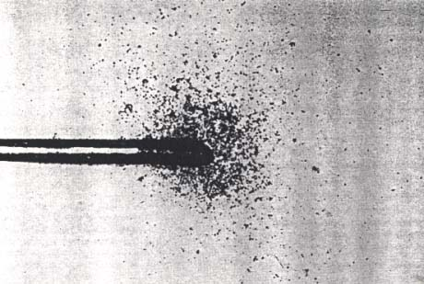



**Wild-type**

**Che-**

The chemoreceptor Tar in *E. coli* senses both aspartate and maltose. In a capillary assay (left), the pond contained saturating amounts of maltose and the capillary was filled with threshold amounts of aspartate and maltose. **1.** Would wild-type bacteria migrate into the capillary? **2.** How would an E. coli mutant missing Tar behave in the capillary assay? **3.** If the Tar mutant was inoculated at the center in the plate assay (right), would its migration resemble the WT pattern or the Che- pattern? Justify.

**1. Even though a single receptor Tar senses two metabolites, one is sensed directly and other via a protein. If their binding sites on Tar are different, wild-type bacteria will migrate into the capillary. 2. The mutant cannot recognize either Asp or Mal, so it will not enter the capillary. 3. E. coli has multiple receptors. The Tar mutant can still detect other metabolites in the rich medium via these other receptors. It would therefore migrate out, but perhaps not as efficiently as wild-type.**

**B.** For each one of the following chemotaxis proteins, predict if their absence will make the bacteria generally non-chemotactic i.e. no response to any of the known attractants: Tsr, Tar, CheZ, CheB, CheR. Justify.

**Absence of the chemoreceptors Tsr or Tar will only abolish chemotaxis to their specific ligands (serine, aspartate). Absence of CheB, CheR or CheZ, will abrogate chemotaxis to all known attractants because these proteins process all attractant signals.**

**(12, 8)**

**3. A.** A Galactose- Permease- *E. coli* mutant has a 10 times lower threshold than wild type *E. coli* as shown in the figure. Why is its threshold lower? **2.** If you know why its threshold is lower, what can you manipulate in the set-up with the mutant to get a profile similar to the wild type? (Hint: add a special mutant to the pond)

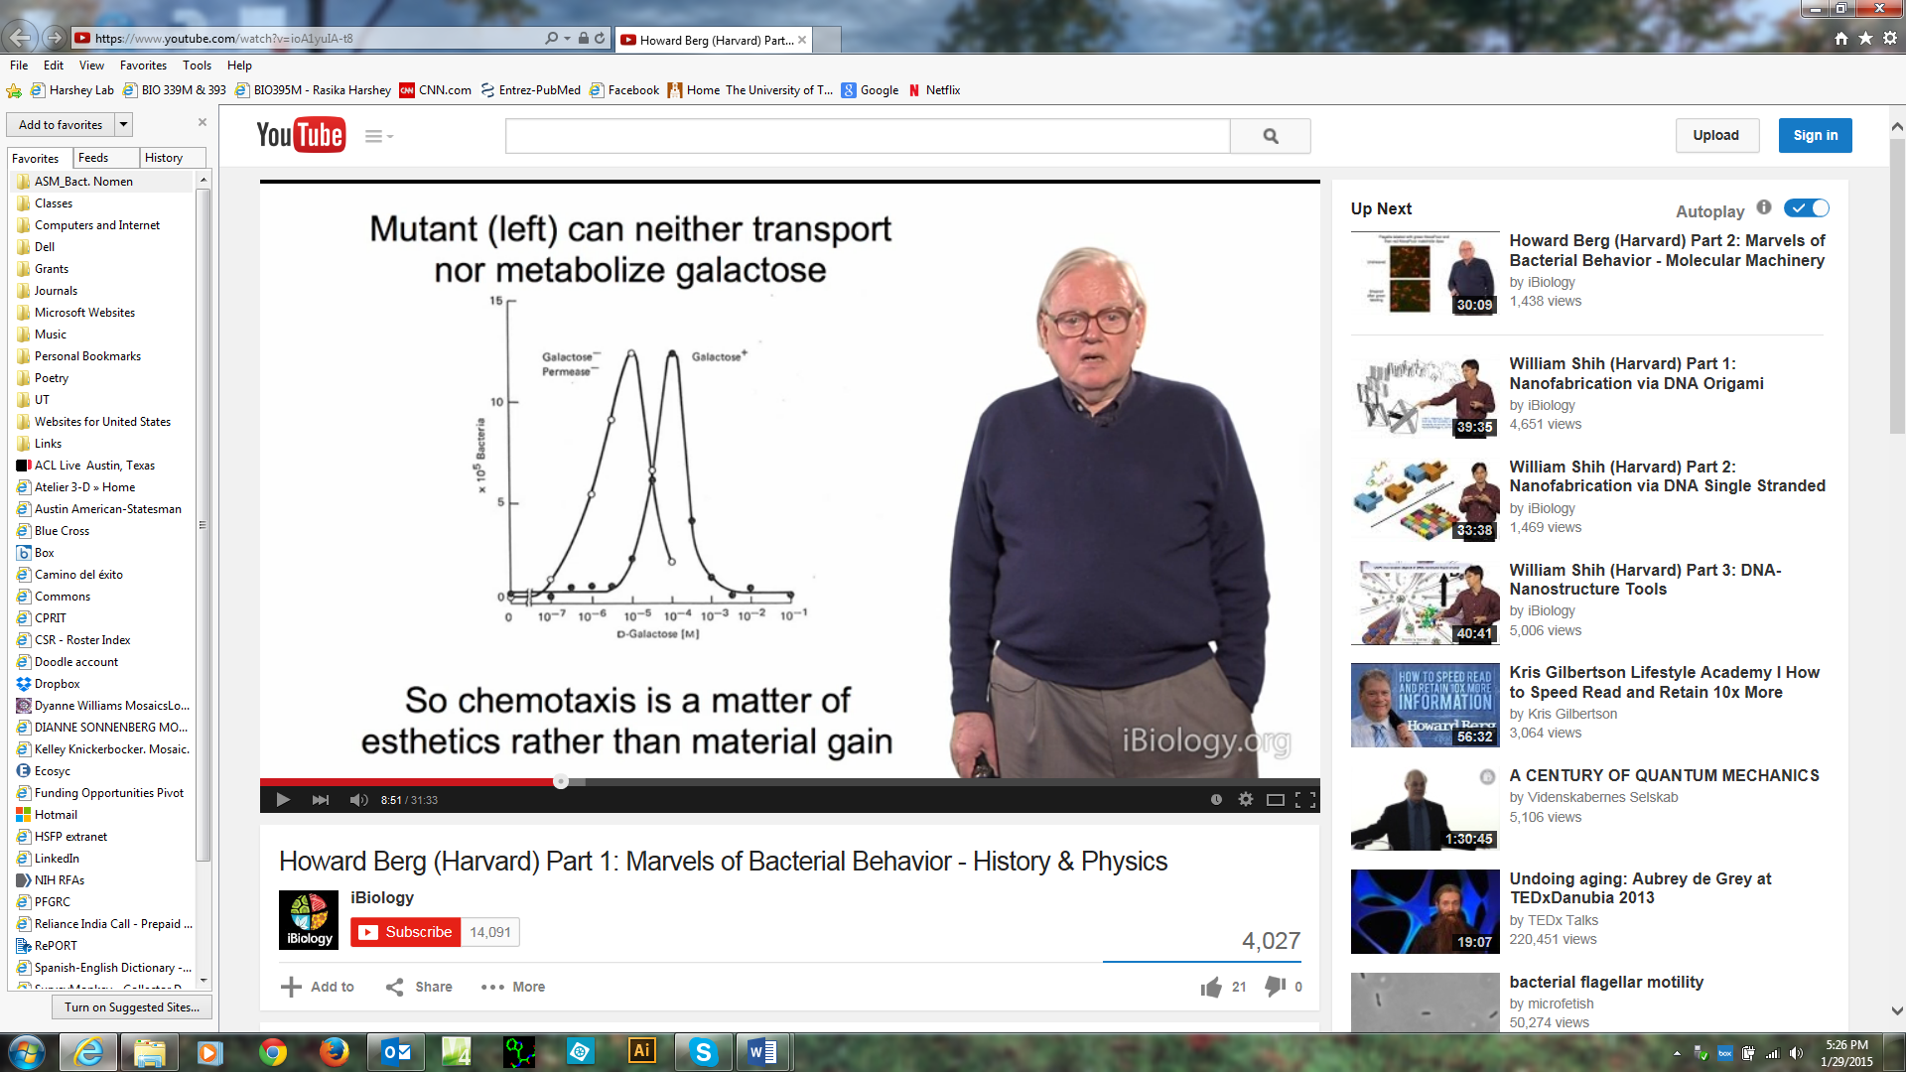**1. Galactose diffuses from the capillary into the pond. The wild type can consume the galactose, thus decreasing its concentration. The mutant can neither transport nor metabolize galactose, therefore the galactose concentrations it experiences in the pond are higher than those the wild type experiences. Since receptor sensitivity is the same in the two strains, the mutant will respond at lower initial galactose concentrations.**

**2. For the profile to be similar, the galactose concentration in the pond must drop in the mutant set-up. Add a non-chemotactic mutant to the pond which is proficient in metabolizing galactose. This mutant will lower the galactose concentrations, but not itself migrate to the capillary.**

**B.** In an isotropic medium, E. coli display a basal level of running and tumbling. Berg follows the tracks of a bacterium swimming in such a medium for 5 min. Approximately how many runs will he see? If the bacteria were placed in an attractant gradient, will the number of runs increase or decrease? Justify.

**(b) ~300 runs, because the mean run length in such an environment is ~1 sec. The number of runs in an attractant gradient will decrease because the run lengths up-gradient increase.**

**(7,7,6)**

**4. A.** Early observations suggested that  phage infect only motile bacteria. The Samuel paper concluded that motility is not required, but motor rotation is. How did they come to such a conclusion?

**The Samuel paper showed that bacteria with straight filaments, which do not generate thrust and hence are non-motile, can be infected by  as long as the filaments are rotating. They also showed that mutants with long hooks can be infected, even though they don’t promote motility.**

**B.**  phage is added to a series of bacterial variants displaying the polymorphic forms shown in the figure below. Will the phage infect and multiply in each of these mutants? Justify your answers.

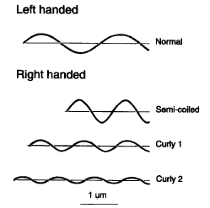

**The phage will infect only the left handed forms and not the right handed ones because the grooves along L forms are thought to favor phage binding and those along the R forms to disfavor binding.**

**C**. Will  phage infect E. coli that do not have the CheA kinase?

**A kinase mutant turns its motors CCW because not CheY~P is being generated.  phage infect CCW cells. So yes.**

**(6, 6, 8)**

**5.** **A.** What are the two components in Two Component signaling? Which residues in these two components take part in reaction chemistry? Name these components in the chemotaxis pathway.

**The Kinase and Response Regulator. His residue in the kinase and Asp residue in the RR. CheA is the kinase and CheY/CheB are the response regulators.**

**B.** What do you think phosphorylation does to a protein and why might it be used in signaling?

**The strong negative charge on a phosphate group changes protein conformation via interaction with other hydrophilic residues in the protein. Such changes can either activate or inhibit a particular protein function.**

**C.** CheB is a two-domain protein, which has the phosphorylation site in the N-terminal domain. Phosphorylation activates the methylesterase activity of CheB. A mutant missing the N-terminal domain (CheBC) is active as a methylesterase. Will this mutant show chemotaxis towards attractants in either the capillary or the plate assay? Justify.

**Phosphorylation must be regulated in order to adapt to the attractant stimulus. After an attractant signal inhibits the kinase, adaptation requires that CheR add Me groups to the receptors, which stimulate the kinase and promote CheB phosphorylation. CheB~P then takes off the Me groups and returns the chemoreceptor conformation to the pre-stimulus state, the methylation content depending on the external attractant concentration. If the mutant is always ‘ON’, its activity is unregulated and hence chemotaxis will be impaired or abolished.**

**(10, 10)**

**6.** **A**. T There are fast and slow steps during the attractant signaling scheme of chemotaxis. What are all the protein conformational changes associated with each of these steps?

**Excitation is fast, Adaptation is slow. In the fast step, conformational changes in the TM, HAMP and MH region of receptors are communicated to CheA. In the slow step, exposed E residues in the MH region of the receptors are methylated by CheR, which resets the receptor conformation to its pre-stimulus state. The phosphorylation/dephosphorylation events during these steps change conformations of CheY and CheB.**

**B.** What two enzymatic changes are directly the result of signal propagation and do these occur in the fast or the slow steps?

**The kinase activity of CheA is inhibited during the fast step. During the slow step, methylation of receptors activates the kinase again, and when it phosphorylates CheB, the methylesterase activity of CheB is stimulated.**

(**14, 6)**

**7. A.** A bacterium traveling in a chemoeffector gradient ‘knows’ whether it is traveling up-gradient or down, and thus has device for comparing its present attractant concentration with that it has experienced in its immediate past. Explain the nature of this device, how it helps the bacterium increase its run length up-gradient, and terminate the run down-gradient.

**Short term memory is provided by receptor methylation, which occurs as soon as bacteria experience an attractant stimulus. This stimulus promotes an immediate run because it inhibits CheA. If the run takes the bacterium up-gradient the kinase remain inhibited as more and more receptors receive the attractant signal. The run is eventually terminated because the receptors get methylated and the CheA kinase is stimulated again. Methylated receptors have a lower affinity for the attractant and are a poor substrate for CheB~P. They will therefore remain methylated and not signal again unless the attractant concentration rises. If the concentration falls, CheB~P will remove the methyl groups and the bias will return to normal.**

**B.** Suppose flagella evolved before the chemotaxis system did in E. coli. How would E. coli have moved in these early times with only flagella but no chemotaxis machinery?

**They would have only run, because there would no CheY to generate tumbles.**